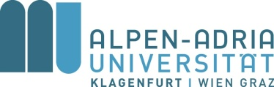

Alpen-Adria-Universitaet Klagenfurt is seeking to make the following appointment:
Postdoc Assistant (f/m)

at the Dept. of Science, Technology & Society Studies. The full-time position (Uni-KV: scheme B1) will initially be limited to 6 years, but provides a tenure track option depending on the signing, and successful fulfillment, of a “qualification agreement” (to acquire assistant and later associate professorship status). The scheduled start of the employment is 1st September 2017.
University graduates with a very good doctoral degree in a social science discipline are encouraged to apply. Applicants must be able to demonstrate profound knowledge in social science theories and methods, in particular in science and technology studies, have proven experience in grant applications and in conducting research projects, as well as in teaching courses at university level. The publication record should include publications in renowned journals and by distinguished academic publishers.
Fluency in English is required (both written and spoken) and the successful candidate is expected to acquire a good level of German language competence within two years.

The application must be submitted electronically in pdf format to Alpen-Adria-Universitaet Klagenfurt, Dekanatekanzlei /Recruiting using the code 310/17 via the link www.aau.at/obf. The deadline for the application is 7th June 2016.

Please find the complete official announcement in German at www.aau.at/jobs. Further information on the university can be obtained from the university website www.aau.at/jobs/information and, more specifically, from www.aau.at/en/jobs/information.

